Onderdelenlijst:
- Pump
- Heating Element
- LED Stript
- 3 x 5 Volt Relay (Relay 1 tot en met 3)
- Raspberry pi 4
- T-Cobbler
- 10kΩ potentiometer
- 220Ω resistor (R1)
- 330Ω resistor (R2)
- 4.7kΩ resistor (R3)
- 2 x 10kΩ resistors (R4 en R5)
- DS18B20 temperature sensor
- Breaboard power supply
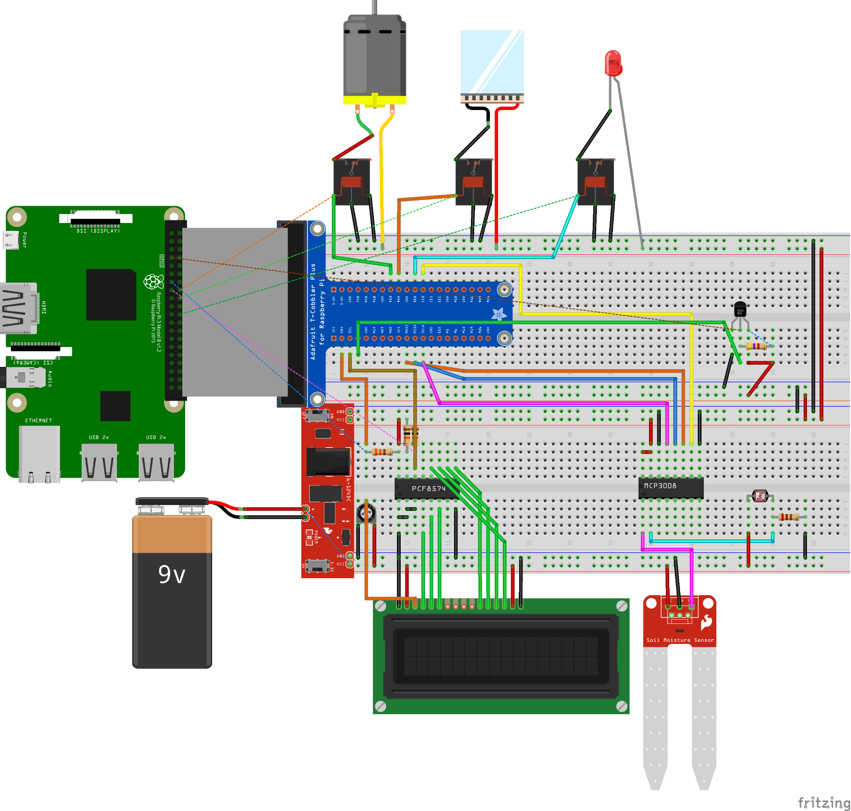
- Soil Moisture sensor
- 16x2 LCD display
- PCF8574 I2C slave
- MCP3008 spi slave
- LDR lichtsensor

